Decision Analysis for Selecting Autonomous Delivery Robot Prototypes for a Leeds Pilot Trial

1. Executive Summary:
AutonomousShipment is preparing a real-world trial of autonomous delivery robots in Leeds to evaluate their suitability for last-mile logistics operations. Due to limited resources, only two robot prototypes can be selected for this trial. Each prototype must align with a distinct business strategy defined by the management team.
This report applies structured decision-making techniques to recommend one robot for each strategy. The first recommendation supports the company’s primary business model of operating at scale and maximising the number of deliveries of large shipments. The second recommendation supports a secondary strategy focused on selling robot technology, where the most valuable intellectual property is expected to be in battery capacity, unit cost, and reliability.
Using the performance data provided in Robot_Info.csv and the stakeholder priorities documented in Management_Priority.xlsx, all seven evaluation criteria were incorporated into the analysis. A multiple-criteria decision analysis (MCDA) framework was used, supported by robustness and sensitivity testing.
Final recommendations:
- Plan 1 (Operate at scale): Gamma
- Plan 2 (Sell robot technology): Delta

2. Business Understanding:
The business objective is to select two autonomous robot prototypes for a limited trial that will inform AutonomousShipment’s future operational and strategic decisions. The trial must provide insight into both large-scale delivery operations and the commercial potential of robot technology.
Two distinct business plans guide the decision:
Plan 1: Operating at scale
The primary business model focuses on maximising delivery volumes, particularly for large shipments. This requires robots with high carrying capacity, cost efficiency, and the ability to operate reliably in real urban environments. Management has conducted a stakeholder analysis and documented the relative importance of decision criteria in Management_Priority.xlsx.
Plan 2: Selling robot technology
The secondary business model focuses on commercialising the technology itself, for example through licensing or direct sales. Given the current state of autonomous delivery systems, management believes that intellectual property value lies primarily in battery technology, cost efficiency, and reliability. Unlike Plan 1, this strategy explicitly acknowledges uncertainty in how important each criterion may be.
The core business question is therefore not only which robots perform well, but which robots best align with each strategy under realistic decision constraints.

3. Data Understanding:
Two datasets were provided by the management team.
Robot_Info.csv contains performance information for seven robot prototypes (Alpha, Bravo, Charlie, Delta, Echo, Foxtrot, and Gamma). Each robot is evaluated against seven criteria:
Criterion | Description | Preference
Carrying Capacity | Load volume (litres) | Higher is better
Battery Size | Hours of operation | Higher is better
Speed | Average speed (km/h) | Higher is better
Mobility | Subjective score out of 5 | Higher is better
Aesthetic | Subjective score out of 10 | Higher is better
Cost per Unit | Unit cost (£) | Lower is better
Reliability | Days until breakdown | Higher is better

Table 1: Raw Robot Performance Data (from Robot_Info.csv)
Robot_Prototype | Alpha | Bravo | Charlie | Delta | Echo | Foxtrot | Gamma
Carrying Capacity | 35 | 50 | 50 | 40 | 55 | 70 | 55
Battery Size | 11 | 6 | 9 | 12 | 10 | 9 | 10
Speed | 15 | 15 | 15 | 25 | 15 | 15 | 18
Mobility | 5 | 4 | 3 | 4 | 2 | 1 | 3
Aesthetic | 10 | 6 | 6 | 3 | 6 | 7 | 9
The data includes both quantitative and qualitative assessments. Visual inspection of the raw data shows trade-offs between robots; some excel in battery and speed but are more expensive, while others are cheaper but have lower reliability.
Management_Priority.xlsx contains qualitative notes from a stakeholder meeting describing the relative importance of each criterion for the primary business model. The file does not provide numeric weights but instead outlines priorities and comparative importance between criteria.

Table 2: Stakeholder Priorities and Criterion Importance (from Management_Priority.xlsx)
Carrying Capacity | This is the most important criterion.
Battery Size | The battery size is more important than reliability, but not as much as mobility.
Speed | The speed is as important as the mobility of the vehicle.
Mobility | After careful deliberation, the mobility is rated 6 out of 10 in terms of importance. We believe that it is an important criterion, but not as important as some others, and that this would likely improve with better tech.
Aesthetic | This is the least important.
Cost Per Unit | The cost is the second most important criterion.
Reliability | This is slightly more important than the aesthetic.

4. Data Preparation:
Several data preparation steps were undertaken to ensure the analysis was suitable and reliable.
- Data validation
No missing values or duplicate entries were detected. All numeric fields were coerced into the appropriate type.
- Normalisation
Because criteria are measured on different scales (GBP, litres, days, subjective scores), all criteria were normalised using min–max scaling to a 0–1 range:
  - For benefit criteria (capacity, battery, reliability, speed, mobility, aesthetic), higher values map closer to 1.
  - For cost per unit (a lower-is-better criterion), the scale was reversed so that lower costs map to higher normalized values.
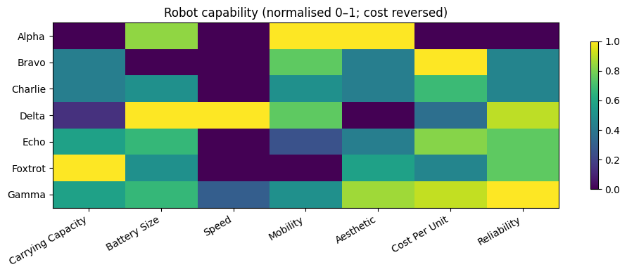
Figure 1: Heatmap of Normalised Robot Performance
- Transparency of assumptions
All transformations are deterministic and reproducible. This allows independent verification of results.

5. Modelling Approach:

5.1 Model Selection
The primary decision model used is the Weighted Sum Model (WSM). After normalisation, each robot receives a weighted sum across all criteria. WSM was chosen for its simplicity, interpretability, and suitability for communicating trade-offs to management.
To validate results, a secondary method, TOPSIS (Technique for Order Preference by Similarity to Ideal Solution), was applied. Results were consistent, confirming model robustness.

5.2 Plan 1 - Management-Led Weighting (Operate at Scale)
The stakeholder priorities from Management_Priority.xlsx were converted to numeric scores based on explicit notes:
Table 3: Derived Numeric Weights for Plan 1
Criterion | Weight Rationale | Assigned Score | Weight (normalised)
Carrying Capacity | Most important | 10 | 0.256
Cost per Unit | Second most important | 9 | 0.128
Mobility | Explicitly rated | 6 | 0.154
Speed | Equal to mobility | 6 | 0.154
Battery Size | More important than reliability | 5 | 0.026
Reliability | Slightly above aesthetic | 2 | 0.231
Aesthetic | Least important | 1 | 0.051
After normalising the sum to 1, these weights were applied in WSM to produce overall robot scores.
Table 4: Probability of Ranking First for Each Robot for Plan 1
Robot_Prototype | P(rank #1)
Gamma | 0.9994
Delta | 0.0006
Alpha | 0.0000
Charlie | 0.0000
Bravo | 0.0000
Echo | 0.0000
Foxtrot | 0.0000
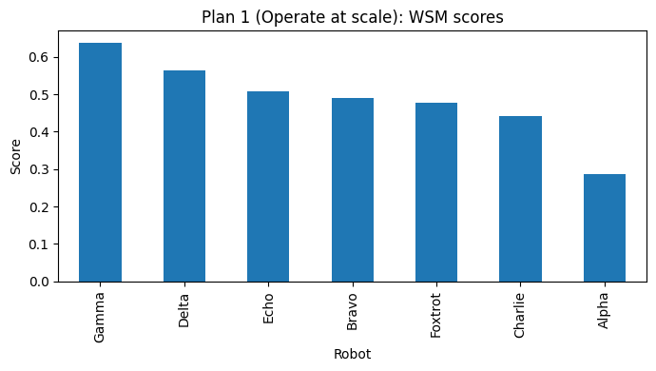
Figure 2: WSM Ranking – Plan 1
Result: Gamma achieved the highest score. Its combination of high carrying capacity, cost efficiency, battery life, and reliability makes it the best fit for high-volume delivery operations.

5.3 Plan 2 - Weight Distribution (Sell Robot Technology)
For the technology-focused strategy, management requested a distribution of importance rather than fixed weights. Expected emphasis was:
- Battery Size: 30%
- Cost per Unit: 30%
- Reliability: 25%
- Remaining criteria: 15%
A Dirichlet distribution generated 20,000 plausible weight vectors, ensuring all criteria remained included. Each robot was scored for each weight set, and the top-ranked robot recorded.
Delta emerged as the top alternative to Gamma, particularly in battery-heavy scenarios. Some robots, including Alpha, Bravo, and Charlie, never ranked first, indicating strategic domination by Gamma and Delta.
Table 5: Probability of Ranking First for Each Robot - Plan 2
Robot_Prototype | P(rank #1)
Gamma | 0.9276
Delta | 0.0724
Alpha | 0.0000
Charlie | 0.0000
Bravo | 0.0000
Echo | 0.0000
Foxtrot | 0.0000
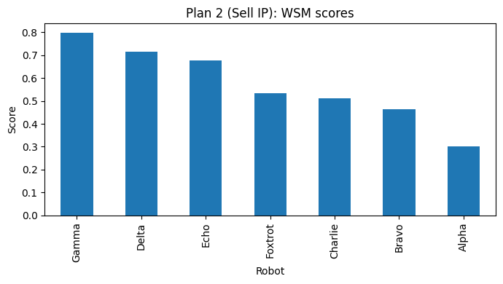
Figure 2: WSM Ranking – Plan 2

6. Evaluation and Robustness:
Evaluation consisted of three steps:
- Cross-method validation
TOPSIS results were consistent with WSM, confirming ranking stability.
- Plan 1 robustness
Monte Carlo simulations of random weight variations within management-defined priority ranges showed Gamma consistently ranked first. This demonstrates low sensitivity to weight assumptions.
- Plan 2 robustness
Under Dirichlet-sampled weight scenarios, Delta frequently emerged as top-ranked for battery-focused configurations, providing valuable complementary insights for technology-commercialisation learning.

7. Conclusion and Recommendations:
The analysis addressed the business requirement of selecting two robot prototypes for a limited Leeds trial using MCDA methods and robust evaluation.
Recommended prototypes:
- Plan 1 (Operate at scale): Gamma
Best aligns with operational priorities due to high carrying capacity, cost efficiency, and reliability.
- Plan 2 (Sell robot technology): Delta
Provides insights into battery performance and technology potential while complementing Gamma in the trial.
If only one robot could be selected, Gamma would satisfy both strategies. However, selecting Gamma and Delta together maximises learning from the trial, supporting both short-term operational success and long-term strategic positioning.

